UNITED STATES
SECURITIES AND EXCHANGE COMMISSION
Washington, D.C. 20549

Form 6-K

REPORT OF FOREIGN PRIVATE ISSUER PURSUANT TO RULE
13a-16 OR 15d-16 UNDER
THE SECURITIES EXCHANGE ACT OF 1934

For the month of July 2026

Commission File Number: 001-34936

Noah Holdings Limited
(Registrant’s name)

333 North Bridge Road, #05-11
Odeon 333
Singapore 188721
+65 6911-8211
(Address of principal executive office)

Indicate by check mark whether the registrant files or will file annual reports under cover Form 20-F or Form 40-F.

Form 20-F ☒ Form 40-F ☐

EXHIBIT INDEX

Exhibit 99.1 | Announcement—Final Dividend for the Year Ended December 31, 2025 (Updated)
Exhibit 99.2 | Announcement—Special Dividend (Updated)
Exhibit 99.3 | Announcement—Payment of Final Dividend and Special Dividend

SIGNATURE

Pursuant to the requirements of the Securities Exchange Act of 1934, the registrant has duly caused this report to be signed on its behalf by the undersigned, thereunto duly authorized.

 | Noah Holdings Limited
 | By: | /s/ Qing Pan
 | Name: | Qing Pan
 | Title: | Chief Financial Officer
Date: July 10, 2026

Exhibit 99.1
 | 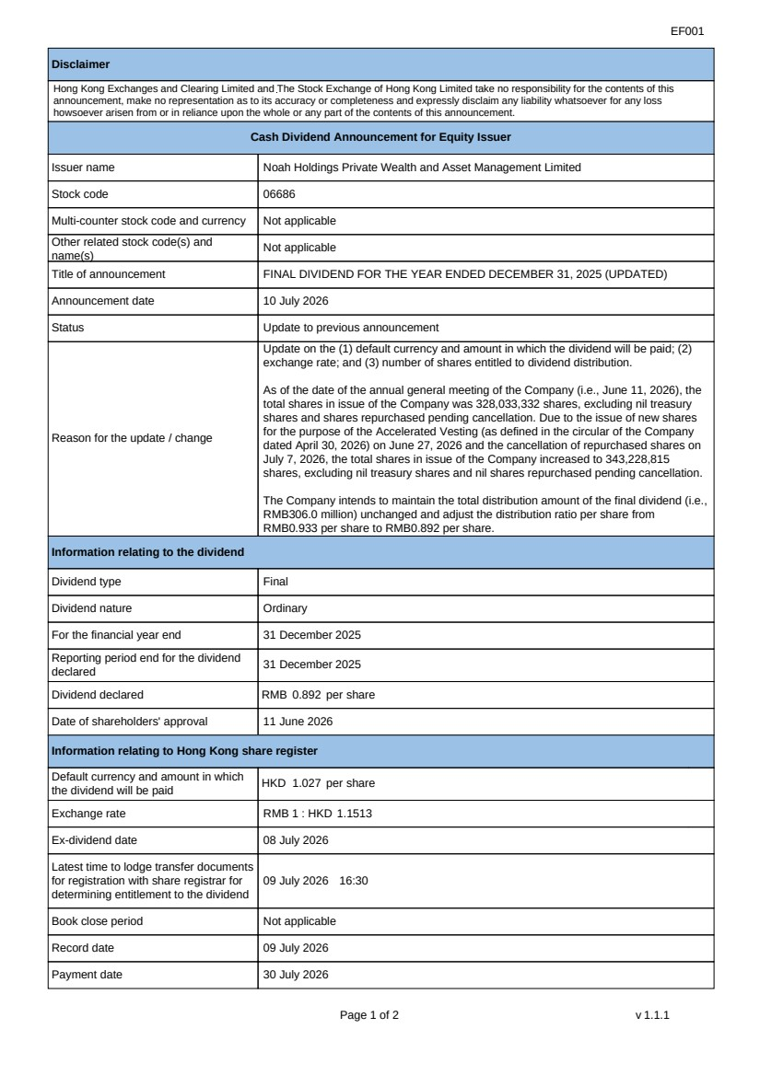 | EF001 Page 1 of 2 v 1.1.1 Disclaimer Hong Kong Exchanges and Clearing Limited and The Stock Exchange of Hong Kong Limited take no responsibility for the contents of this announcement, make no representation as to its accuracy or completeness and expressly disclaim any liability whatsoever for any loss howsoever arisen from or in reliance upon the whole or any part of the contents of this announcement. Cash Dividend Announcement for Equity Issuer Issuer name Noah Holdings Private Wealth and Asset Management Limited Stock code 06686 Multi-counter stock code and currency Not applicable Other related stock code(s) and name(s) Not applicable Title of announcement FINAL DIVIDEND FOR THE YEAR ENDED DECEMBER 31, 2025 (UPDATED) Announcement date 10 July 2026 Status Update to previous announcement Reason for the update / change Update on the (1) default currency and amount in which the dividend will be paid; (2) exchange rate; and (3) number of shares entitled to dividend distribution. As of the date of the annual general meeting of the Company (i.e., June 11, 2026), the total shares in issue of the Company was 328,033,332 shares, excluding nil treasury shares and shares repurchased pending cancellation. Due to the issue of new shares for the purpose of the Accelerated Vesting (as defined in the circular of the Company dated April 30, 2026) on June 27, 2026 and the cancellation of repurchased shares on July 7, 2026, the total shares in issue of the Company increased to 343,228,815 shares, excluding nil treasury shares and nil shares repurchased pending cancellation. The Company intends to maintain the total distribution amount of the final dividend (i.e., RMB306.0 million) unchanged and adjust the distribution ratio per share from RMB0.933 per share to RMB0.892 per share. Information relating to the dividend Dividend type Final Dividend nature Ordinary For the financial year end 31 December 2025 Reporting period end for the dividend declared 31 December 2025 Dividend declared RMB 0.892 per share Date of shareholders' approval 11 June 2026 Information relating to Hong Kong share register Default currency and amount in which the dividend will be paid HKD 1.027 per share Exchange rate RMB 1 : HKD 1.1513 Ex-dividend date 08 July 2026 Latest time to lodge transfer documents for registration with share registrar for determining entitlement to the dividend 09 July 2026 16:30 Book close period Not applicable Record date 09 July 2026 Payment date 30 July 2026
 | 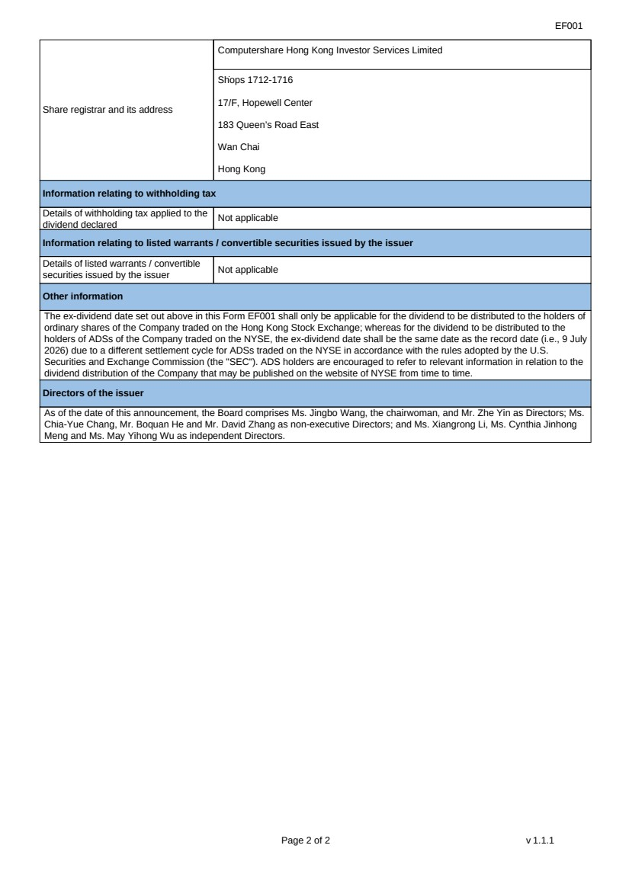 | EF001 Page 2 of 2 v 1.1.1 Share registrar and its address Computershare Hong Kong Investor Services Limited Shops 1712-1716 17/F, Hopewell Center 183 Queen’s Road East Wan Chai Hong Kong Information relating to withholding tax Details of withholding tax applied to the dividend declared Not applicable Information relating to listed warrants / convertible securities issued by the issuer Details of listed warrants / convertible securities issued by the issuer Not applicable Other information The ex-dividend date set out above in this Form EF001 shall only be applicable for the dividend to be distributed to the holders of ordinary shares of the Company traded on the Hong Kong Stock Exchange; whereas for the dividend to be distributed to the holders of ADSs of the Company traded on the NYSE, the ex-dividend date shall be the same date as the record date (i.e., 9 July 2026) due to a different settlement cycle for ADSs traded on the NYSE in accordance with the rules adopted by the U.S. Securities and Exchange Commission (the "SEC"). ADS holders are encouraged to refer to relevant information in relation to the dividend distribution of the Company that may be published on the website of NYSE from time to time. Directors of the issuer As of the date of this announcement, the Board comprises Ms. Jingbo Wang, the chairwoman, and Mr. Zhe Yin as Directors; Ms. Chia-Yue Chang, Mr. Boquan He and Mr. David Zhang as non-executive Directors; and Ms. Xiangrong Li, Ms. Cynthia Jinhong Meng and Ms. May Yihong Wu as independent Directors.
Exhibit 99.2
 | 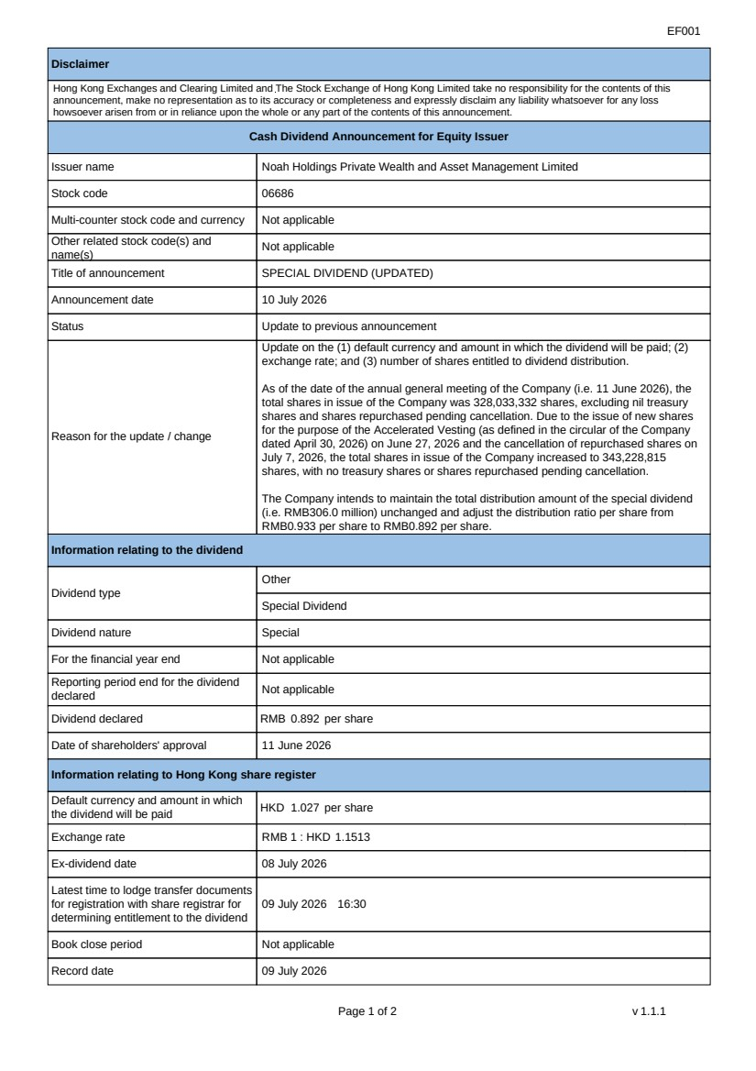 | EF001 Page 1 of 2 v 1.1.1 Disclaimer Hong Kong Exchanges and Clearing Limited and The Stock Exchange of Hong Kong Limited take no responsibility for the contents of this announcement, make no representation as to its accuracy or completeness and expressly disclaim any liability whatsoever for any loss howsoever arisen from or in reliance upon the whole or any part of the contents of this announcement. Cash Dividend Announcement for Equity Issuer Issuer name Noah Holdings Private Wealth and Asset Management Limited Stock code 06686 Multi-counter stock code and currency Not applicable Other related stock code(s) and name(s) Not applicable Title of announcement SPECIAL DIVIDEND (UPDATED) Announcement date 10 July 2026 Status Update to previous announcement Reason for the update / change Update on the (1) default currency and amount in which the dividend will be paid; (2) exchange rate; and (3) number of shares entitled to dividend distribution. As of the date of the annual general meeting of the Company (i.e. 11 June 2026), the total shares in issue of the Company was 328,033,332 shares, excluding nil treasury shares and shares repurchased pending cancellation. Due to the issue of new shares for the purpose of the Accelerated Vesting (as defined in the circular of the Company dated April 30, 2026) on June 27, 2026 and the cancellation of repurchased shares on July 7, 2026, the total shares in issue of the Company increased to 343,228,815 shares, with no treasury shares or shares repurchased pending cancellation. The Company intends to maintain the total distribution amount of the special dividend (i.e. RMB306.0 million) unchanged and adjust the distribution ratio per share from RMB0.933 per share to RMB0.892 per share. Information relating to the dividend Dividend type Other Special Dividend Dividend nature Special For the financial year end Not applicable Reporting period end for the dividend declared Not applicable Dividend declared RMB 0.892 per share Date of shareholders' approval 11 June 2026 Information relating to Hong Kong share register Default currency and amount in which the dividend will be paid HKD 1.027 per share Exchange rate RMB 1 : HKD 1.1513 Ex-dividend date 08 July 2026 Latest time to lodge transfer documents for registration with share registrar for determining entitlement to the dividend 09 July 2026 16:30 Book close period Not applicable Record date 09 July 2026
 | 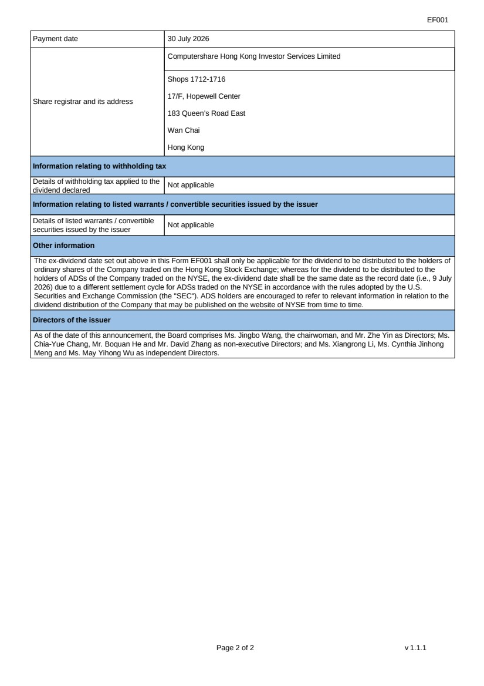 | EF001 Page 2 of 2 v 1.1.1 Payment date 30 July 2026 Share registrar and its address Computershare Hong Kong Investor Services Limited Shops 1712-1716 17/F, Hopewell Center 183 Queen’s Road East Wan Chai Hong Kong Information relating to withholding tax Details of withholding tax applied to the dividend declared Not applicable Information relating to listed warrants / convertible securities issued by the issuer Details of listed warrants / convertible securities issued by the issuer Not applicable Other information The ex-dividend date set out above in this Form EF001 shall only be applicable for the dividend to be distributed to the holders of ordinary shares of the Company traded on the Hong Kong Stock Exchange; whereas for the dividend to be distributed to the holders of ADSs of the Company traded on the NYSE, the ex-dividend date shall be the same date as the record date (i.e., 9 July 2026) due to a different settlement cycle for ADSs traded on the NYSE in accordance with the rules adopted by the U.S. Securities and Exchange Commission (the "SEC"). ADS holders are encouraged to refer to relevant information in relation to the dividend distribution of the Company that may be published on the website of NYSE from time to time. Directors of the issuer As of the date of this announcement, the Board comprises Ms. Jingbo Wang, the chairwoman, and Mr. Zhe Yin as Directors; Ms. Chia-Yue Chang, Mr. Boquan He and Mr. David Zhang as non-executive Directors; and Ms. Xiangrong Li, Ms. Cynthia Jinhong Meng and Ms. May Yihong Wu as independent Directors.

Exhibit 99.3

Hong Kong Exchanges and Clearing Limited and The Stock Exchange of Hong Kong Limited take no responsibility for the contents of this announcement, make no representation as to its accuracy or completeness and expressly disclaim any liability whatsoever for any loss howsoever arising from or in reliance upon the whole or any part of the contents of this announcement.

Noah Holdings

Noah Holdings Private Wealth and Asset Management Limited
諾亞控股私人財富資產管理有限公司
(Incorporated in the Cayman Islands with limited liability under the name Noah Holdings Limited and carrying on business in Hong Kong as Noah Holdings Private Wealth and Asset Management Limited)
(NYSE Ticker Symbol: NOAH; HKEX Stock Code: 6686)

PAYMENT OF FINAL DIVIDEND AND SPECIAL DIVIDEND

Reference is made to the announcement (“Announcement”) of Noah Holdings Private Wealth and Asset Management Limited (the “Company”) dated June 11, 2026 in relation to the payment of final dividend and special dividend, respectively. Unless the context requires otherwise, capitalized terms used in this announcement shall have the same meanings as those defined in the Announcement.

The Board is pleased to announce that the Company will distribute (i) the Final Dividend of HK$1.027 per Share (for registered holders of the ordinary shares in Hong Kong) in Hong Kong dollars or US$0.131 per Share (for ADS holders and for holders of ordinary shares whose shares are registered on the Company’s principal share register in the Cayman Islands) in U.S. dollars in respect of the year ended December 31, 2025, calculated based on the Final Dividend of RMB0.892 per Share; and (ii) the Special Dividend of HK$1.027 per Share (for registered holders of the ordinary shares in Hong Kong) in Hong Kong dollars or US$0.131 per Share (for ADS holders and for holders of ordinary shares whose shares are registered on the Company’s principal share register in the Cayman Islands) in U.S. dollars, calculated based on the Special Dividend of RMB0.892 per Share, both with reference to the effective noon buying rate for July 2, 2026 as set forth in the H.10 statistical release of the U.S. Federal Reserve Board and the number of issued Shares (excluding treasury Shares) of 343,228,815 entitled to dividend distribution as of the Dividend Record Date (i.e., July 9, 2026).

For the distribution of the Final Dividend and Special Dividend to ADS holders, the final amounts of approximately US$0.655 and US$0.655 per ADS (subject to applicable tax and depositary fees) are payable in U.S. dollars to the Company’s ADS holders through the depositary bank subject to the foreign exchange rate adjustment on the date of settlement in accordance with the terms of the deposit agreement.

1

The Final Dividend and Special Dividend are expected to be distributed on or around July 30, 2026 to eligible Shareholders, and on or around August 6, 2026 to eligible ADS holders. Shareholders and ADS holders should seek professional advice from their own tax advisors regarding the possible tax implications of the payment of the Final Dividend and the Special Dividend.

By order of the Board
Noah Holdings Private Wealth and Asset Management Limited
Jingbo Wang
Chairwoman of the Board

Hong Kong, July 10, 2026

As of the date of this announcement, the Board comprises Ms. Jingbo Wang, the chairwoman, and Mr. Zhe Yin as Directors; Ms. Chia-Yue Chang, Mr. Boquan He and Mr. David Zhang as non-executive Directors; and Ms. Xiangrong Li, Ms. Cynthia Jinhong Meng and Ms. May Yihong Wu as independent Directors.

2

