UNITED STATES

SECURITIES AND EXCHANGE COMMISSION

Washington, D.C. 20549

Form 6-K

REPORT OF FOREIGN PRIVATE ISSUER PURSUANT TO RULE

13a-16 OR 15d-16 UNDER

THE SECURITIES EXCHANGE ACT OF 1934

For the month of June 2026

Commission File Number: 001-34936

Noah Holdings Limited

(Registrant’s name)

333 North Bridge Road, #05-11

Odeon 333

Singapore 188721

+65 6911-8211

(Address of principal executive office)

Indicate by check mark whether the registrant files or will file annual reports under cover Form 20-F or Form 40-F.

Form 20-F ☒ Form 40-F ☐

 |  |  | EXHIBIT INDEX
Exhibit 99.1 |  | Final Dividend for the Year Ended December 31, 2025 (Updated)
Exhibit 99.2 |  | Special Dividend (Updated)

SIGNATURE

Pursuant to the requirements of the Securities Exchange Act of 1934, the registrant has duly caused this report to be signed on its behalf by the undersigned, thereunto duly authorized.

Noah Holdings Limited

By: /s/ Qing Pan

Name: Qing Pan

Title: Chief Financial Officer

Date: June 12, 2026

Exhibit 99.1
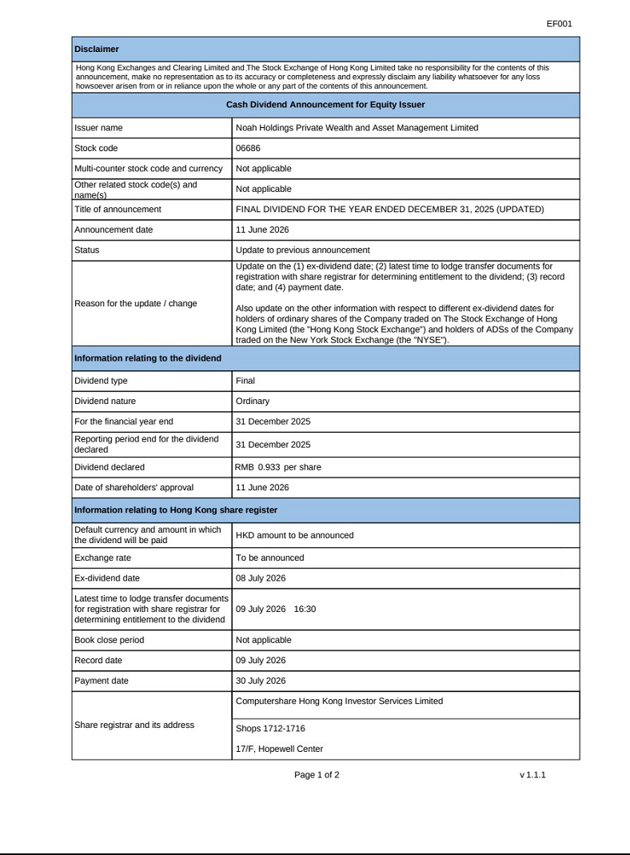

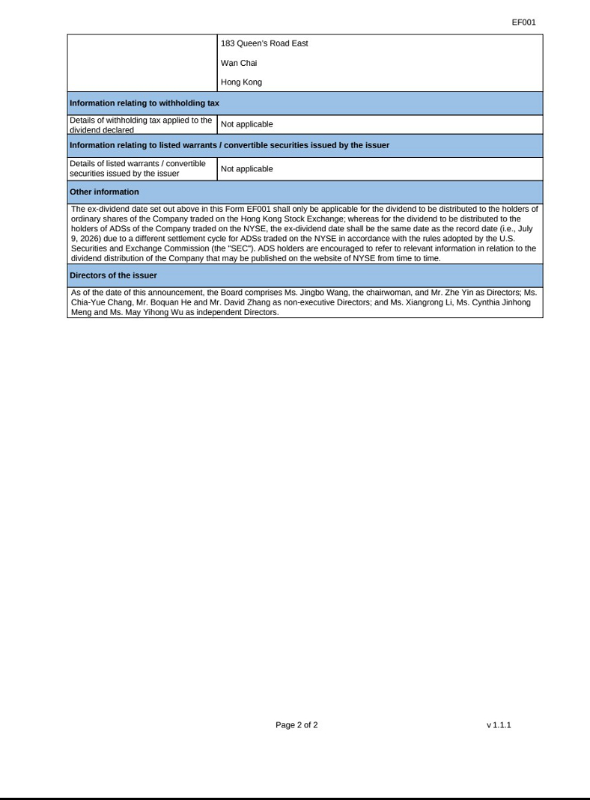

Exhibit 99.2


