UNITED STATES
SECURITIES AND EXCHANGE COMMISSION
Washington, D.C. 20549

Form 6-K

REPORT OF FOREIGN PRIVATE ISSUER PURSUANT TO RULE
13a-16 OR 15d-16 UNDER
THE SECURITIES EXCHANGE ACT OF 1934

For the month of July 2026

Commission File Number: 001-34936

Noah Holdings Limited
(Registrant’s name)

333 North Bridge Road, #05-11
Odeon 333
Singapore 188721
+65 6911-8211
(Address of principal executive office)

Indicate by check mark whether the registrant files or will file annual reports under cover Form 20-F or Form 40-F.

Form 20-F ☒ Form 40-F ☐

EXHIBIT INDEX

Exhibit 99.1 | Next Day Disclosure Return Dated July 8, 2026
Exhibit 99.2 | Monthly Return for Equity Issuer and Hong Kong Depositary Receipts listed under Chapter 19B of the Exchange Listing Rules on Movements in Securities

SIGNATURE

Pursuant to the requirements of the Securities Exchange Act of 1934, the registrant has duly caused this report to be signed on its behalf by the undersigned, thereunto duly authorized.

 | Noah Holdings Limited
 | By: | /s/ Qing Pan
 | Name: | Qing Pan
 | Title: | Chief Financial Officer
Date: July 9, 2026

Exhibit 99.1
 | 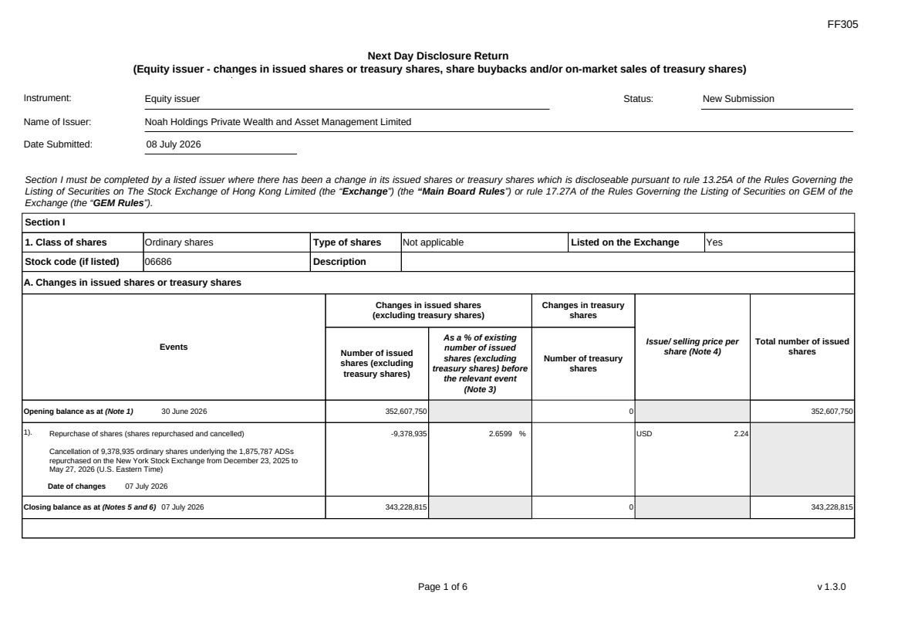 | FF305 Page 1 of 6 v 1.3.0 Next Day Disclosure Return (Equity issuer - changes in issued shares or treasury shares, share buybacks and/or on-market sales of treasury shares) Instrument: Equity issuer Status: New Submission Name of Issuer: Noah Holdings Private Wealth and Asset Management Limited Date Submitted: 08 July 2026 Section I must be completed by a listed issuer where there has been a change in its issued shares or treasury shares which is discloseable pursuant to rule 13.25A of the Rules Governing the Listing of Securities on The Stock Exchange of Hong Kong Limited (the “Exchange”) (the “Main Board Rules”) or rule 17.27A of the Rules Governing the Listing of Securities on GEM of the Exchange (the “GEM Rules”). Section I 1. Class of shares Ordinary shares Type of shares Not applicable Listed on the Exchange Yes Stock code (if listed) 06686 Description A. Changes in issued shares or treasury shares Events Changes in issued shares (excluding treasury shares) Number of issued shares (excluding treasury shares) As a % of existing number of issued shares (excluding treasury shares) before the relevant event (Note 3) Changes in treasury shares Number of treasury shares Issue/ selling price per share (Note 4) Total number of issued shares Opening balance as at (Note 1) 30 June 2026 352,607,750 0 352,607,750 1). Repurchase of shares (shares repurchased and cancelled) Cancellation of 9,378,935 ordinary shares underlying the 1,875,787 ADSs repurchased on the New York Stock Exchange from December 23, 2025 to May 27, 2026 (U.S. Eastern Time) Date of changes 07 July 2026 -9,378,935 2.6599 % USD 2.24 Closing balance as at (Notes 5 and 6) 07 July 2026 343,228,815 0 343,228,815
 | 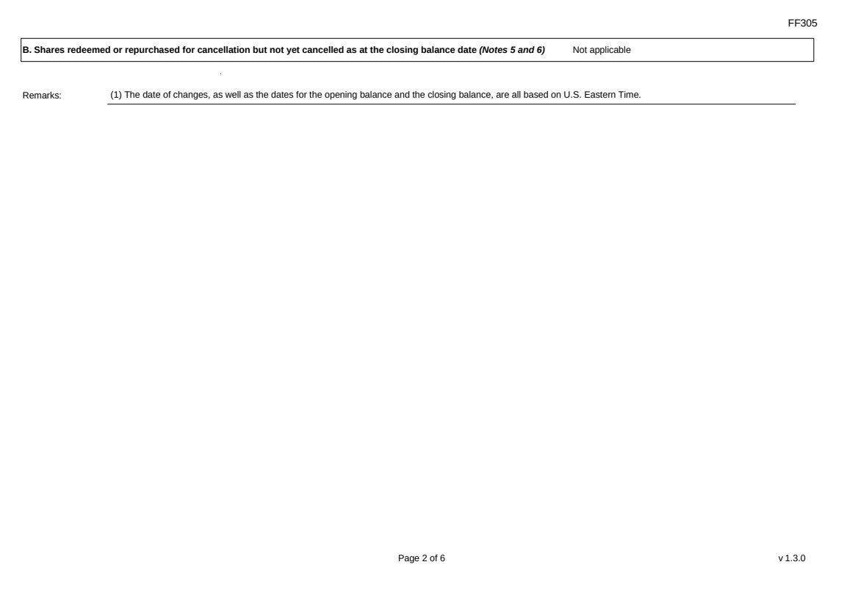 | FF305 Page 2 of 6 v 1.3.0 B. Shares redeemed or repurchased for cancellation but not yet cancelled as at the closing balance date (Notes 5 and 6) Not applicable Remarks: (1) The date of changes, as well as the dates for the opening balance and the closing balance, are all based on U.S. Eastern Time.
 | 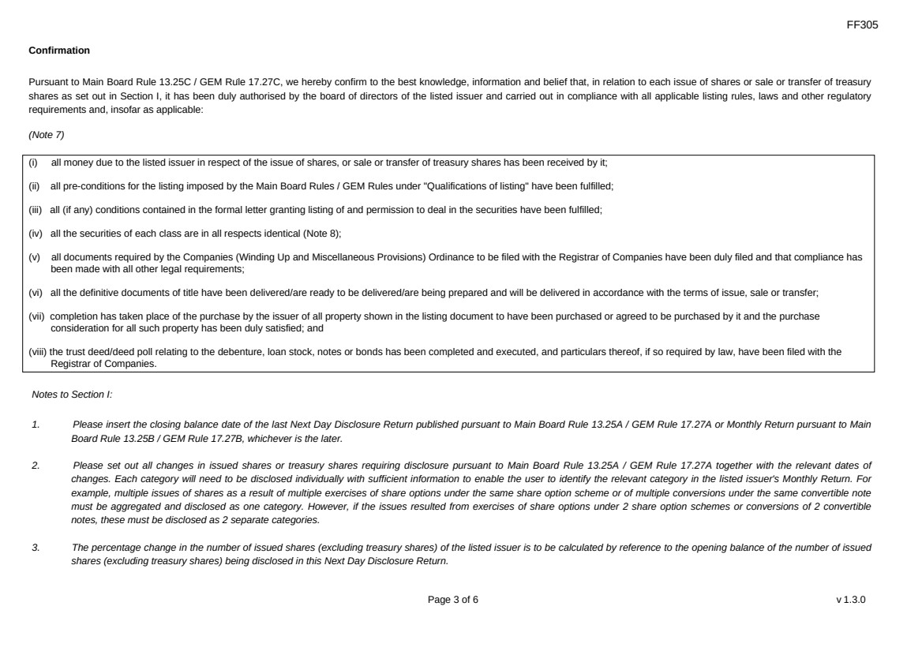 | FF305 Page 3 of 6 v 1.3.0 Confirmation Pursuant to Main Board Rule 13.25C / GEM Rule 17.27C, we hereby confirm to the best knowledge, information and belief that, in relation to each issue of shares or sale or transfer of treasury shares as set out in Section I, it has been duly authorised by the board of directors of the listed issuer and carried out in compliance with all applicable listing rules, laws and other regulatory requirements and, insofar as applicable: (Note 7) (i) all money due to the listed issuer in respect of the issue of shares, or sale or transfer of treasury shares has been received by it; (ii) all pre-conditions for the listing imposed by the Main Board Rules / GEM Rules under "Qualifications of listing" have been fulfilled; (iii) all (if any) conditions contained in the formal letter granting listing of and permission to deal in the securities have been fulfilled; (iv) all the securities of each class are in all respects identical (Note 8); (v) all documents required by the Companies (Winding Up and Miscellaneous Provisions) Ordinance to be filed with the Registrar of Companies have been duly filed and that compliance has been made with all other legal requirements; (vi) all the definitive documents of title have been delivered/are ready to be delivered/are being prepared and will be delivered in accordance with the terms of issue, sale or transfer; (vii) completion has taken place of the purchase by the issuer of all property shown in the listing document to have been purchased or agreed to be purchased by it and the purchase consideration for all such property has been duly satisfied; and (viii) the trust deed/deed poll relating to the debenture, loan stock, notes or bonds has been completed and executed, and particulars thereof, if so required by law, have been filed with the Registrar of Companies. Notes to Section I: 1. Please insert the closing balance date of the last Next Day Disclosure Return published pursuant to Main Board Rule 13.25A / GEM Rule 17.27A or Monthly Return pursuant to Main Board Rule 13.25B / GEM Rule 17.27B, whichever is the later. 2. Please set out all changes in issued shares or treasury shares requiring disclosure pursuant to Main Board Rule 13.25A / GEM Rule 17.27A together with the relevant dates of changes. Each category will need to be disclosed individually with sufficient information to enable the user to identify the relevant category in the listed issuer's Monthly Return. For example, multiple issues of shares as a result of multiple exercises of share options under the same share option scheme or of multiple conversions under the same convertible note must be aggregated and disclosed as one category. However, if the issues resulted from exercises of share options under 2 share option schemes or conversions of 2 convertible notes, these must be disclosed as 2 separate categories. 3. The percentage change in the number of issued shares (excluding treasury shares) of the listed issuer is to be calculated by reference to the opening balance of the number of issued shares (excluding treasury shares) being disclosed in this Next Day Disclosure Return.
 | 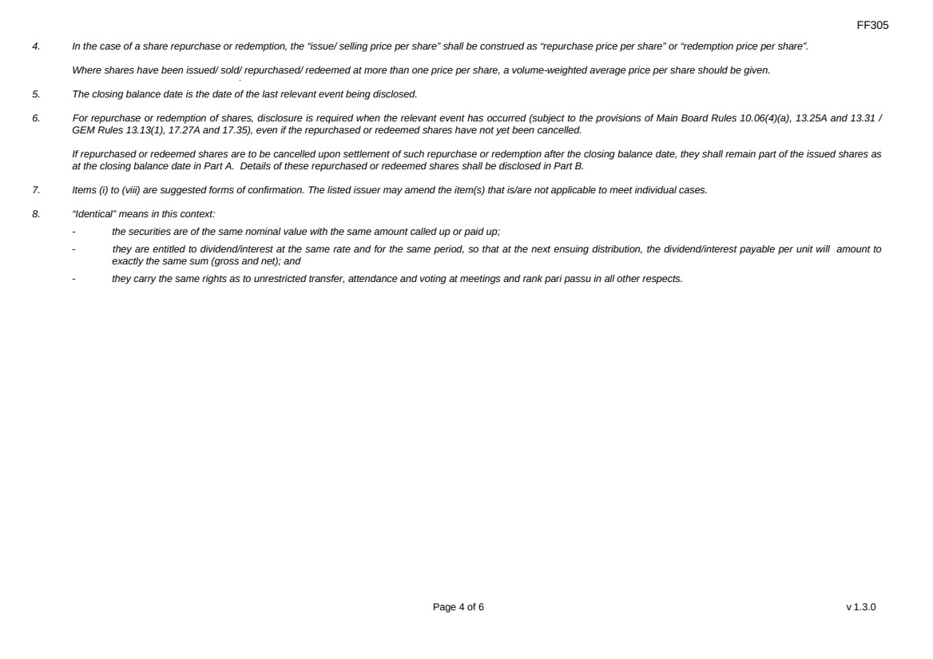 | FF305 Page 4 of 6 v 1.3.0 4. In the case of a share repurchase or redemption, the “issue/ selling price per share” shall be construed as “repurchase price per share” or “redemption price per share”. Where shares have been issued/ sold/ repurchased/ redeemed at more than one price per share, a volume-weighted average price per share should be given. 5. The closing balance date is the date of the last relevant event being disclosed. 6. For repurchase or redemption of shares, disclosure is required when the relevant event has occurred (subject to the provisions of Main Board Rules 10.06(4)(a), 13.25A and 13.31 / GEM Rules 13.13(1), 17.27A and 17.35), even if the repurchased or redeemed shares have not yet been cancelled. If repurchased or redeemed shares are to be cancelled upon settlement of such repurchase or redemption after the closing balance date, they shall remain part of the issued shares as at the closing balance date in Part A. Details of these repurchased or redeemed shares shall be disclosed in Part B. 7. Items (i) to (viii) are suggested forms of confirmation. The listed issuer may amend the item(s) that is/are not applicable to meet individual cases. 8. “Identical” means in this context: - the securities are of the same nominal value with the same amount called up or paid up; - they are entitled to dividend/interest at the same rate and for the same period, so that at the next ensuing distribution, the dividend/interest payable per unit will amount to exactly the same sum (gross and net); and - they carry the same rights as to unrestricted transfer, attendance and voting at meetings and rank pari passu in all other respects.
 | 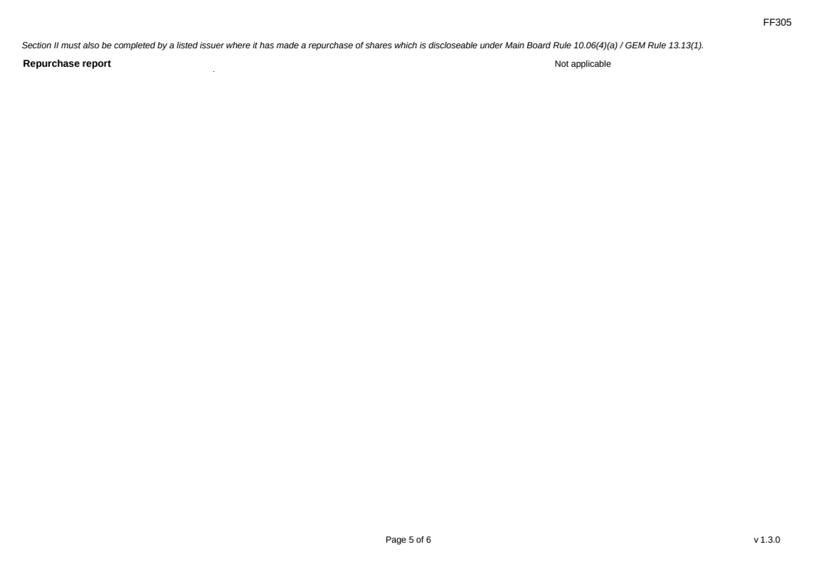 | FF305 Page 5 of 6 v 1.3.0 Section II must also be completed by a listed issuer where it has made a repurchase of shares which is discloseable under Main Board Rule 10.06(4)(a) / GEM Rule 13.13(1). Repurchase report Not applicable
 | 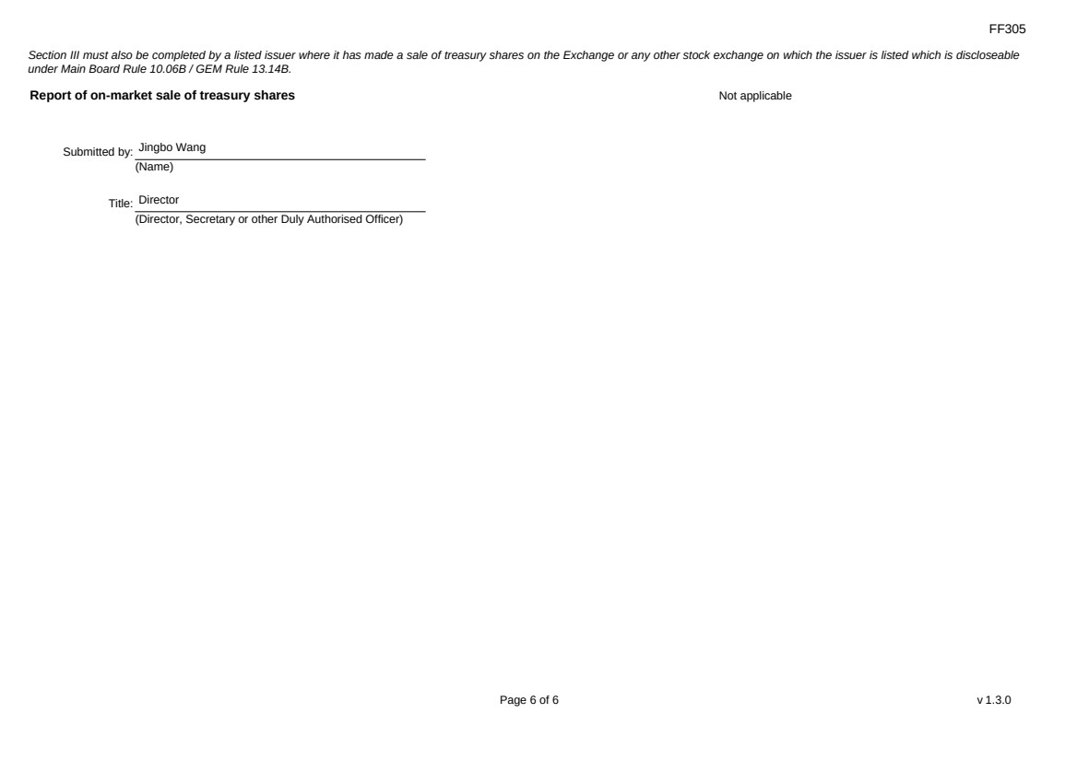 | FF305 Page 6 of 6 v 1.3.0 Section III must also be completed by a listed issuer where it has made a sale of treasury shares on the Exchange or any other stock exchange on which the issuer is listed which is discloseable under Main Board Rule 10.06B / GEM Rule 13.14B. Report of on-market sale of treasury shares Not applicable Submitted by: Jingbo Wang (Name) Title: Director (Director, Secretary or other Duly Authorised Officer)
Exhibit 99.2

 | 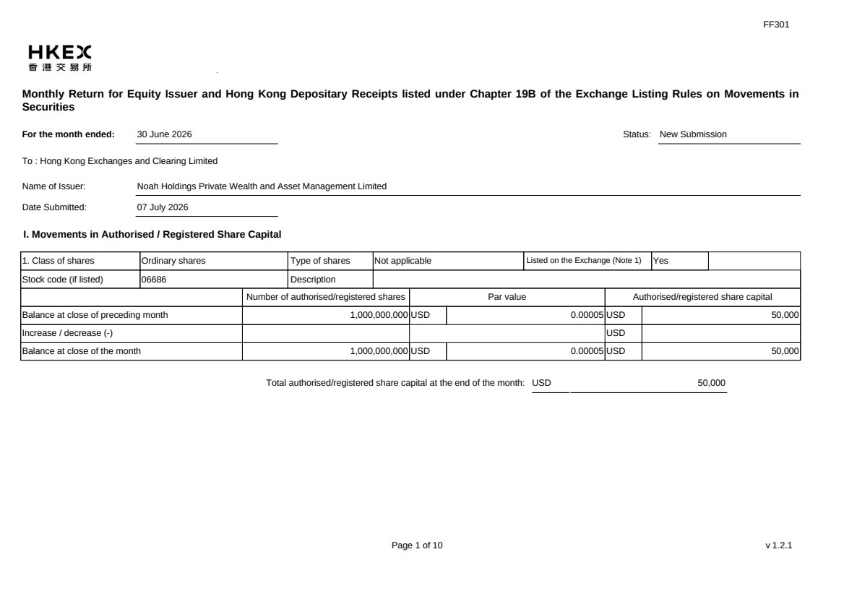 | FF301 Page 1 of 10 v 1.2.1 Monthly Return for Equity Issuer and Hong Kong Depositary Receipts listed under Chapter 19B of the Exchange Listing Rules on Movements in Securities For the month ended: 30 June 2026 Status: New Submission To : Hong Kong Exchanges and Clearing Limited Name of Issuer: Noah Holdings Private Wealth and Asset Management Limited Date Submitted: 07 July 2026 I. Movements in Authorised / Registered Share Capital 1. Class of shares Ordinary shares Type of shares Not applicable Listed on the Exchange (Note 1) Yes Stock code (if listed) 06686 Description Number of authorised/registered shares Par value Authorised/registered share capital Balance at close of preceding month 1,000,000,000 USD 0.00005 USD 50,000 Increase / decrease (-) USD Balance at close of the month 1,000,000,000 USD 0.00005 USD 50,000 Total authorised/registered share capital at the end of the month: USD 50,000
 | 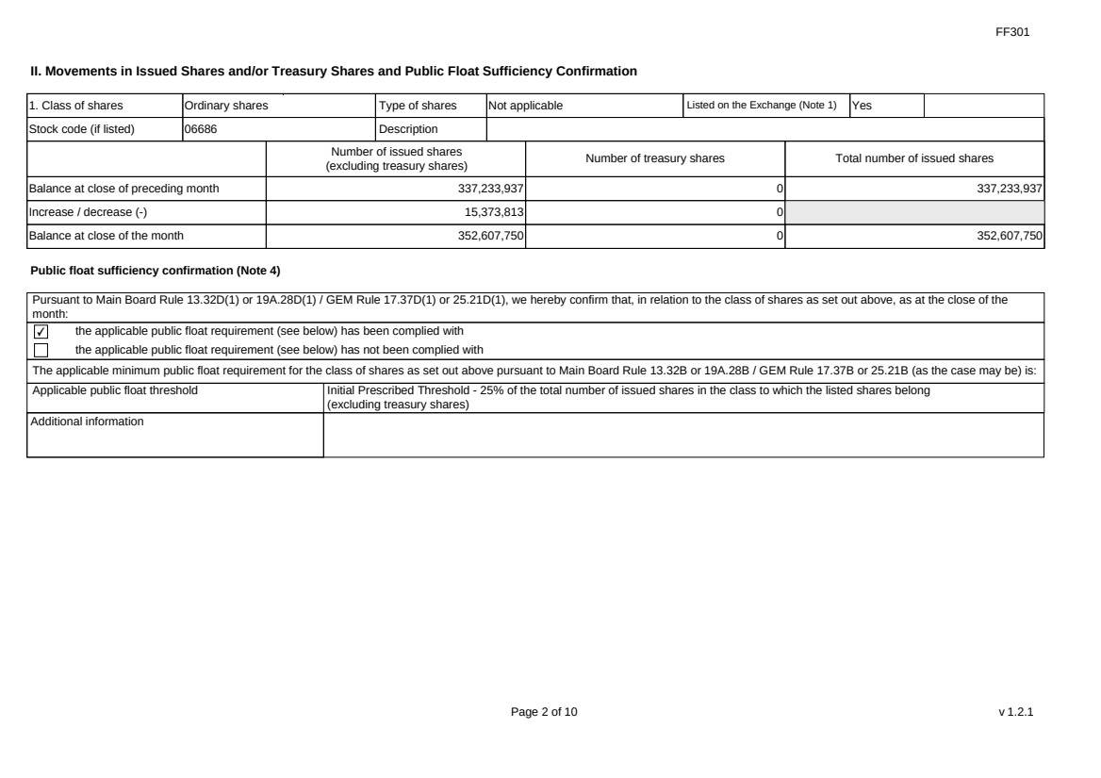 | FF301 Page 2 of 10 v 1.2.1 II. Movements in Issued Shares and/or Treasury Shares and Public Float Sufficiency Confirmation 1. Class of shares Ordinary shares Type of shares Not applicable Listed on the Exchange (Note 1) Yes Stock code (if listed) 06686 Description Number of issued shares (excluding treasury shares) Number of treasury shares Total number of issued shares Balance at close of preceding month 337,233,937 0 337,233,937 Increase / decrease (-) 15,373,813 0 Balance at close of the month 352,607,750 0 352,607,750 Public float sufficiency confirmation (Note 4) Pursuant to Main Board Rule 13.32D(1) or 19A.28D(1) / GEM Rule 17.37D(1) or 25.21D(1), we hereby confirm that, in relation to the class of shares as set out above, as at the close of the month: ✔ the applicable public float requirement (see below) has been complied with the applicable public float requirement (see below) has not been complied with The applicable minimum public float requirement for the class of shares as set out above pursuant to Main Board Rule 13.32B or 19A.28B / GEM Rule 17.37B or 25.21B (as the case may be) is: Applicable public float threshold Initial Prescribed Threshold - 25% of the total number of issued shares in the class to which the listed shares belong (excluding treasury shares) Additional information
 | 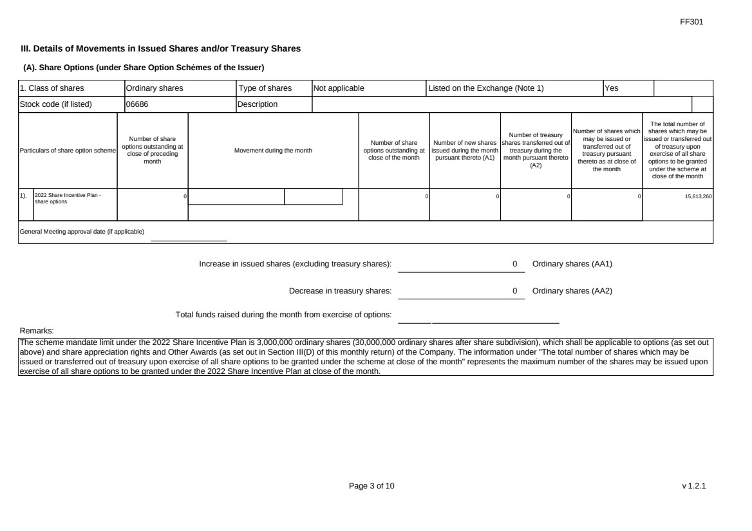 | FF301 Page 3 of 10 v 1.2.1 III. Details of Movements in Issued Shares and/or Treasury Shares (A). Share Options (under Share Option Schemes of the Issuer) 1. Class of shares Ordinary shares Type of shares Not applicable Listed on the Exchange (Note 1) Yes Stock code (if listed) 06686 Description Particulars of share option scheme Number of share options outstanding at close of preceding month Movement during the month Number of share options outstanding at close of the month Number of new shares issued during the month pursuant thereto (A1) Number of treasury shares transferred out of treasury during the month pursuant thereto (A2) Number of shares which may be issued or transferred out of treasury pursuant thereto as at close of the month The total number of shares which may be issued or transferred out of treasury upon exercise of all share options to be granted under the scheme at close of the month 1). 2022 Share Incentive Plan - share options 0 0 0 0 0 15,613,260 General Meeting approval date (if applicable) Increase in issued shares (excluding treasury shares): 0 Ordinary shares (AA1) Decrease in treasury shares: 0 Ordinary shares (AA2) Total funds raised during the month from exercise of options: Remarks: The scheme mandate limit under the 2022 Share Incentive Plan is 3,000,000 ordinary shares (30,000,000 ordinary shares after share subdivision), which shall be applicable to options (as set out above) and share appreciation rights and Other Awards (as set out in Section III(D) of this monthly return) of the Company. The information under "The total number of shares which may be issued or transferred out of treasury upon exercise of all share options to be granted under the scheme at close of the month" represents the maximum number of the shares may be issued upon exercise of all share options to be granted under the 2022 Share Incentive Plan at close of the month.
 |  | FF301 Page 4 of 10 v 1.2.1 (B). Warrants to Issue Shares of the Issuer Not applicable
 |  | FF301 Page 5 of 10 v 1.2.1 (C). Convertibles (i.e. Convertible into Shares of the Issuer) Not applicable
 | 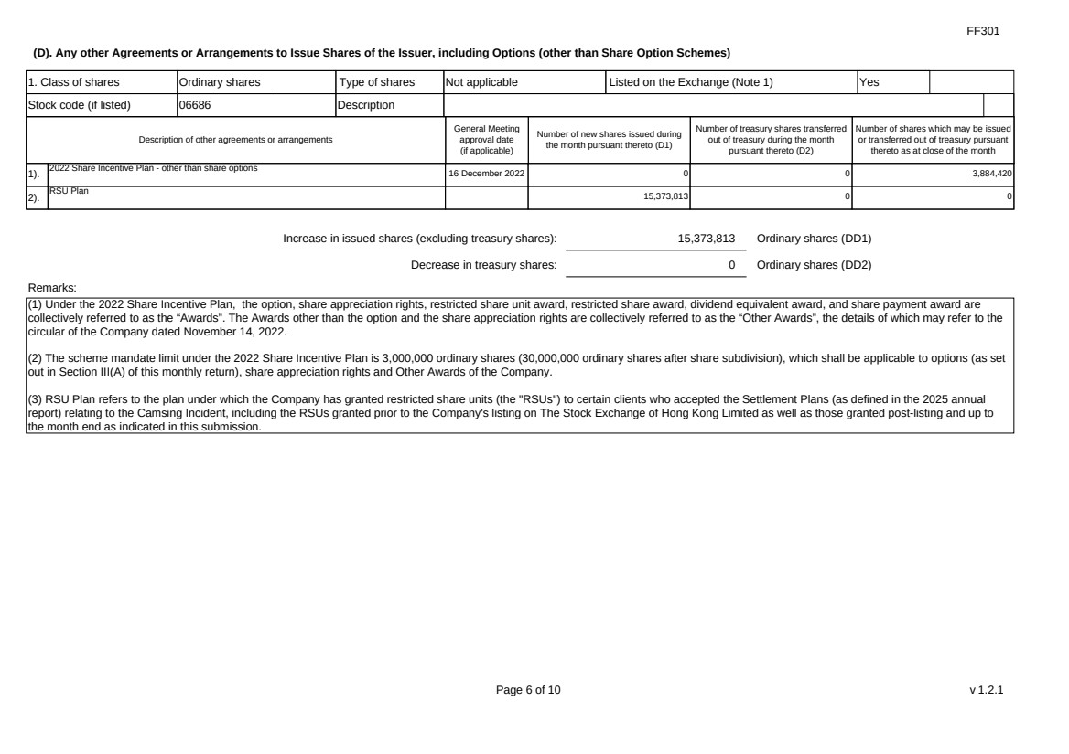 | FF301 Page 6 of 10 v 1.2.1 (D). Any other Agreements or Arrangements to Issue Shares of the Issuer, including Options (other than Share Option Schemes) 1. Class of shares Ordinary shares Type of shares Not applicable Listed on the Exchange (Note 1) Yes Stock code (if listed) 06686 Description Description of other agreements or arrangements General Meeting approval date (if applicable) Number of new shares issued during the month pursuant thereto (D1) Number of treasury shares transferred out of treasury during the month pursuant thereto (D2) Number of shares which may be issued or transferred out of treasury pursuant thereto as at close of the month 1). 2022 Share Incentive Plan - other than share options 16 December 2022 0 0 3,884,420 2). RSU Plan 15,373,813 0 0 Increase in issued shares (excluding treasury shares): 15,373,813 Ordinary shares (DD1) Decrease in treasury shares: 0 Ordinary shares (DD2) Remarks: (1) Under the 2022 Share Incentive Plan, the option, share appreciation rights, restricted share unit award, restricted share award, dividend equivalent award, and share payment award are collectively referred to as the “Awards”. The Awards other than the option and the share appreciation rights are collectively referred to as the “Other Awards”, the details of which may refer to the circular of the Company dated November 14, 2022. (2) The scheme mandate limit under the 2022 Share Incentive Plan is 3,000,000 ordinary shares (30,000,000 ordinary shares after share subdivision), which shall be applicable to options (as set out in Section III(A) of this monthly return), share appreciation rights and Other Awards of the Company. (3) RSU Plan refers to the plan under which the Company has granted restricted share units (the "RSUs") to certain clients who accepted the Settlement Plans (as defined in the 2025 annual report) relating to the Camsing Incident, including the RSUs granted prior to the Company's listing on The Stock Exchange of Hong Kong Limited as well as those granted post-listing and up to the month end as indicated in this submission.
 | 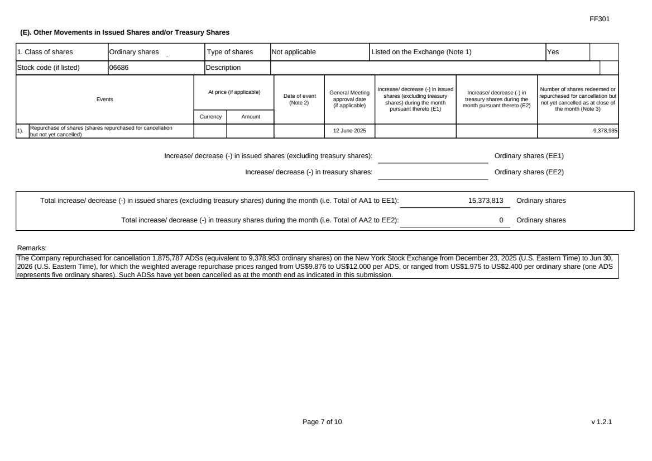 | FF301 Page 7 of 10 v 1.2.1 (E). Other Movements in Issued Shares and/or Treasury Shares 1. Class of shares Ordinary shares Type of shares Not applicable Listed on the Exchange (Note 1) Yes Stock code (if listed) 06686 Description Events At price (if applicable) Currency Amount Date of event (Note 2) General Meeting approval date (if applicable) Increase/ decrease (-) in issued shares (excluding treasury shares) during the month pursuant thereto (E1) Increase/ decrease (-) in treasury shares during the month pursuant thereto (E2) Number of shares redeemed or repurchased for cancellation but not yet cancelled as at close of the month (Note 3) 1). Repurchase of shares (shares repurchased for cancellation but not yet cancelled) 12 June 2025 -9,378,935 Increase/ decrease (-) in issued shares (excluding treasury shares): Ordinary shares (EE1) Increase/ decrease (-) in treasury shares: Ordinary shares (EE2) Total increase/ decrease (-) in issued shares (excluding treasury shares) during the month (i.e. Total of AA1 to EE1): 15,373,813 Ordinary shares Total increase/ decrease (-) in treasury shares during the month (i.e. Total of AA2 to EE2): 0 Ordinary shares Remarks: The Company repurchased for cancellation 1,875,787 ADSs (equivalent to 9,378,953 ordinary shares) on the New York Stock Exchange from December 23, 2025 (U.S. Eastern Time) to Jun 30, 2026 (U.S. Eastern Time), for which the weighted average repurchase prices ranged from US$9.876 to US$12.000 per ADS, or ranged from US$1.975 to US$2.400 per ordinary share (one ADS represents five ordinary shares). Such ADSs have yet been cancelled as at the month end as indicated in this submission.
 | 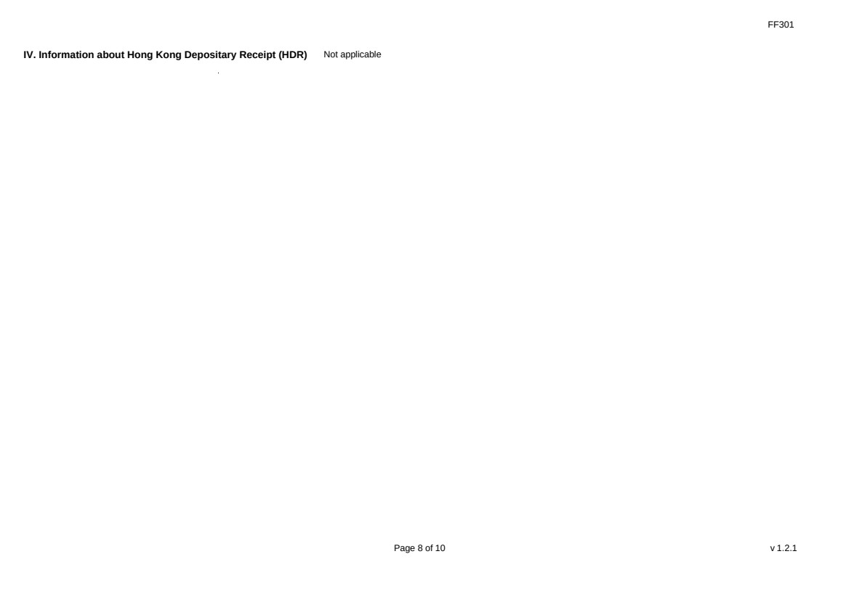 | FF301 Page 8 of 10 v 1.2.1 IV. Information about Hong Kong Depositary Receipt (HDR) Not applicable
 | 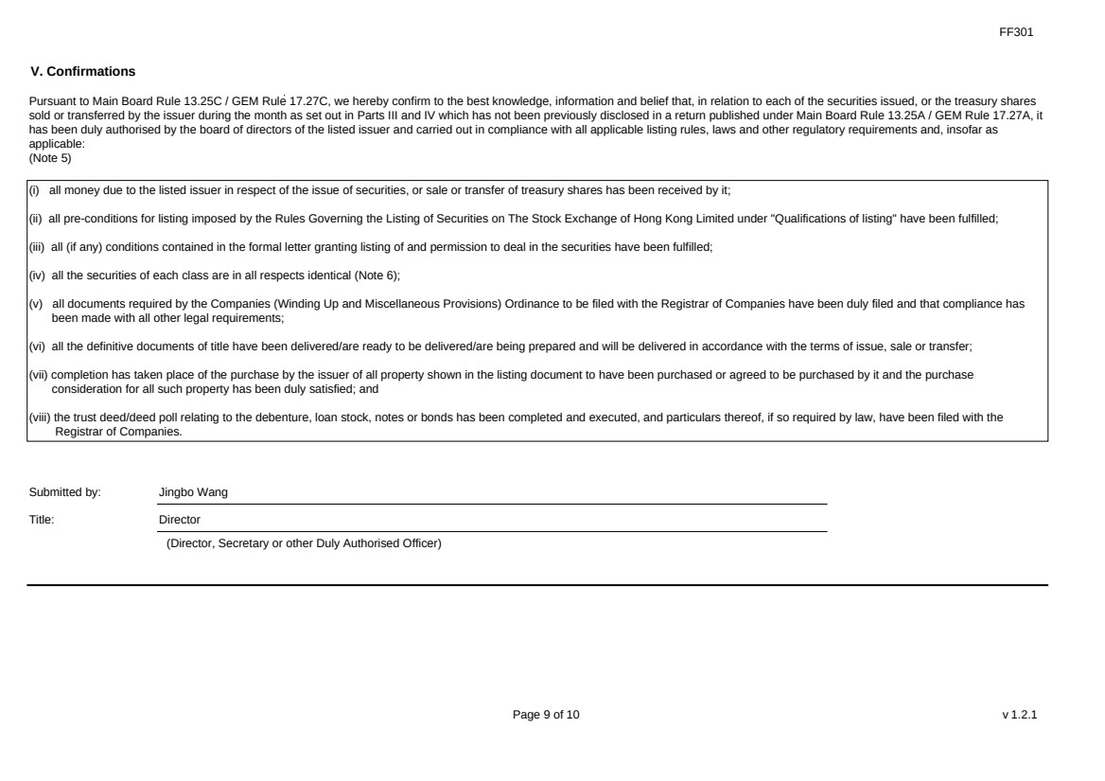 | FF301 Page 9 of 10 v 1.2.1 V. Confirmations Pursuant to Main Board Rule 13.25C / GEM Rule 17.27C, we hereby confirm to the best knowledge, information and belief that, in relation to each of the securities issued, or the treasury shares sold or transferred by the issuer during the month as set out in Parts III and IV which has not been previously disclosed in a return published under Main Board Rule 13.25A / GEM Rule 17.27A, it has been duly authorised by the board of directors of the listed issuer and carried out in compliance with all applicable listing rules, laws and other regulatory requirements and, insofar as applicable: (Note 5) (i) all money due to the listed issuer in respect of the issue of securities, or sale or transfer of treasury shares has been received by it; (ii) all pre-conditions for listing imposed by the Rules Governing the Listing of Securities on The Stock Exchange of Hong Kong Limited under "Qualifications of listing" have been fulfilled; (iii) all (if any) conditions contained in the formal letter granting listing of and permission to deal in the securities have been fulfilled; (iv) all the securities of each class are in all respects identical (Note 6); (v) all documents required by the Companies (Winding Up and Miscellaneous Provisions) Ordinance to be filed with the Registrar of Companies have been duly filed and that compliance has been made with all other legal requirements; (vi) all the definitive documents of title have been delivered/are ready to be delivered/are being prepared and will be delivered in accordance with the terms of issue, sale or transfer; (vii) completion has taken place of the purchase by the issuer of all property shown in the listing document to have been purchased or agreed to be purchased by it and the purchase consideration for all such property has been duly satisfied; and (viii) the trust deed/deed poll relating to the debenture, loan stock, notes or bonds has been completed and executed, and particulars thereof, if so required by law, have been filed with the Registrar of Companies. Submitted by: Jingbo Wang Title: Director (Director, Secretary or other Duly Authorised Officer)
 | 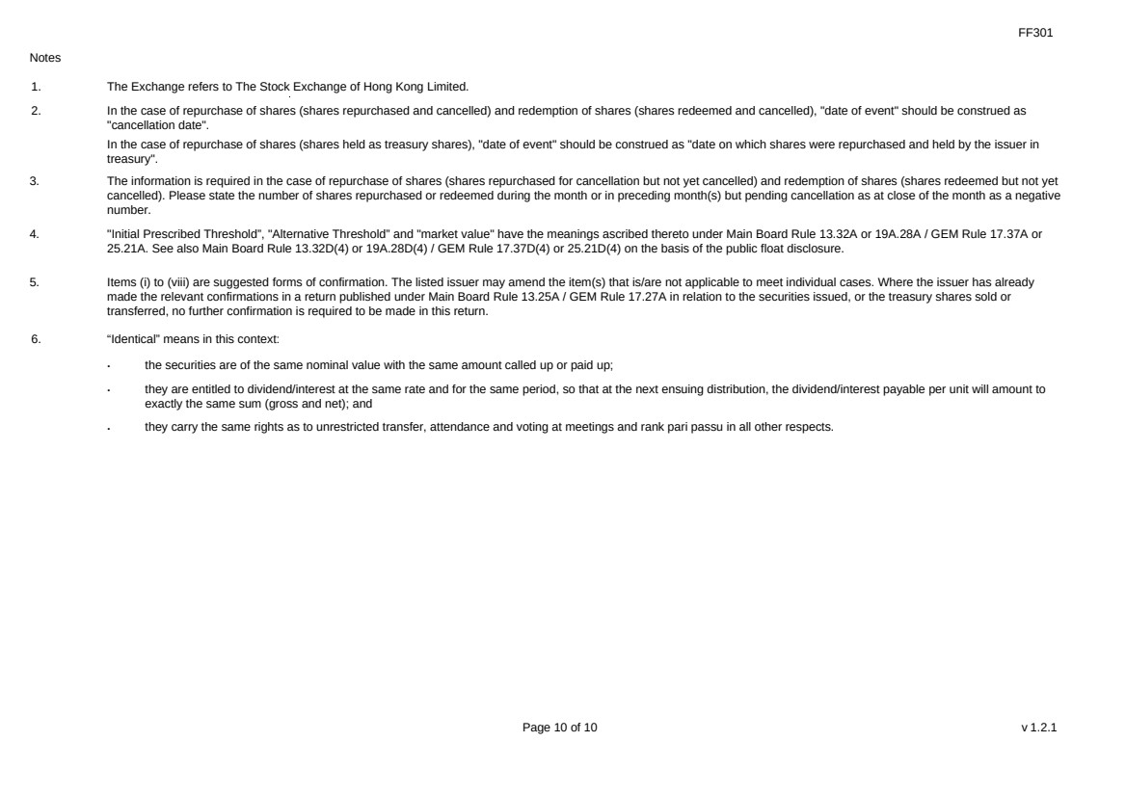 | FF301 Page 10 of 10 v 1.2.1 Notes 1. The Exchange refers to The Stock Exchange of Hong Kong Limited. 2. In the case of repurchase of shares (shares repurchased and cancelled) and redemption of shares (shares redeemed and cancelled), "date of event" should be construed as "cancellation date". In the case of repurchase of shares (shares held as treasury shares), "date of event" should be construed as "date on which shares were repurchased and held by the issuer in treasury". 3. The information is required in the case of repurchase of shares (shares repurchased for cancellation but not yet cancelled) and redemption of shares (shares redeemed but not yet cancelled). Please state the number of shares repurchased or redeemed during the month or in preceding month(s) but pending cancellation as at close of the month as a negative number. 4. "Initial Prescribed Threshold”, "Alternative Threshold” and "market value" have the meanings ascribed thereto under Main Board Rule 13.32A or 19A.28A / GEM Rule 17.37A or 25.21A. See also Main Board Rule 13.32D(4) or 19A.28D(4) / GEM Rule 17.37D(4) or 25.21D(4) on the basis of the public float disclosure. 5. Items (i) to (viii) are suggested forms of confirmation. The listed issuer may amend the item(s) that is/are not applicable to meet individual cases. Where the issuer has already made the relevant confirmations in a return published under Main Board Rule 13.25A / GEM Rule 17.27A in relation to the securities issued, or the treasury shares sold or transferred, no further confirmation is required to be made in this return. 6. “Identical” means in this context: ． the securities are of the same nominal value with the same amount called up or paid up; ． they are entitled to dividend/interest at the same rate and for the same period, so that at the next ensuing distribution, the dividend/interest payable per unit will amount to exactly the same sum (gross and net); and ． they carry the same rights as to unrestricted transfer, attendance and voting at meetings and rank pari passu in all other respects.

